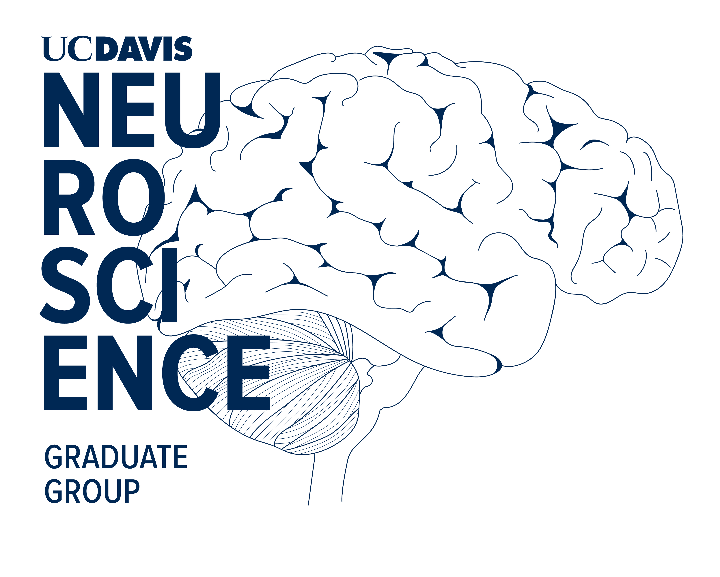

**Individual Development Plan for Predoctoral Students in the Neuroscience Graduate Group**

What is an Individual Development Plan?

“A goal without a plan is a wish.” - French writer, Antoine de Saint-Exupery (1900-1944)

An Individual Development Plan (IDP) for graduate students is an individually-tailored career development tool. It was created to help graduate students prioritize and set short and long-term goals, develop and implement a plan of action, and periodically assess progress in order to achieve their career objectives and move into the U.S. biomedical workforce.

An effective IDP is a dynamic, moving document as student goals will likely evolve over time in graduate school. IDPs are designed for students to take ownership of their career and obtain valuable feedback through effective communication with mentors and Graduate Group leadership. An IDP is helpful at any stage of a student’s graduate career.

Overview of the IDP Process

1. Complete a self-assessment. Assess your current skills and competencies.
2. Formulate goals for the upcoming year.
3. Assess progress at the end of the year.
4. Implement the IDP. Revise as needed.
5. Return to step 1.

All materials here are based on:

<http://education.scripps.edu/postdoctoral/professional_development/files/TSRI-Grad-IDP-long.pdf>

<http://myidp.sciencecareers.org/>

<http://www.faseb.org/portals/2/pdfs/opa/idp.pdf>

<http://www.grad.umn.edu/sites/grad.umn.edu/files/idpgradpdf_1.pdf>

This IDP is adapted from one designed by Dr. James Trimmer and Dr. Gayathri Gomes for use in the Training Program in Molecular and Cellular Biology (MCB) at the University of California Davis.

**Individual Development Plan**

Name: Click here to enter text.

Date: Click here to enter text.

Mentor’s Name: Click here to enter text.

Additional advisors (if any): Click here to enter text.

Thesis Committee Members (if advanced to candidacy): Click here to enter text.

General Questions:

1. How many years have you been in graduate school? Click here to enter text.
2. Have you chosen a dissertation topic? If yes, state the title of your dissertation.

Click here to enter text.

1. Please provide a brief overview of your research project.

Click here to enter text.

1. Do you have a “Next Step Career Goal”? (Postdoctoral training, job, etc. – Don’t be alarmed if you don’t have a career goal yet.)

Click here to enter text.

**Step 1: Self-assessment**

**1A. Assess your strengths, weaknesses and skills**

Evaluate your skills and abilities in the following areas where,

5 = Highly proficient

1 = Needs improvement

|  |  |  |  |  |  |  |
| --- | --- | --- | --- | --- | --- | --- |
| **Overall Core Scientific Knowledge** | | 1 | 2 | 3 | 4 | 5 |
|  | Knowledge of literature in the field | 1 | 2 | 3 | 4 | 5 |
|  | Knowledge of literature related to project | 1 | 2 | 3 | 4 | 5 |
|  | Knowledge area: | 1 | 2 | 3 | 4 | 5 |
|  | Knowledge area: | 1 | 2 | 3 | 4 | 5 |
|  |  |  |  |  |  |  |
| **Laboratory or Bench Skills (e.g., microscopy, animal skills):** | |  | | | | |
|  | Skill set: | 1 | 2 | 3 | 4 | 5 |
|  | Skill set: | 1 | 2 | 3 | 4 | 5 |
|  | Skill set: | 1 | 2 | 3 | 4 | 5 |
|  | Other: (define) | 1 | 2 | 3 | 4 | 5 |
|  |  |  |  |  |  |  |
| **General Research Skills (e.g., designing experiments, creativity):** | |  | | | | |
|  | Designing experiments | 1 | 2 | 3 | 4 | 5 |
|  | Analytical skills | 1 | 2 | 3 | 4 | 5 |
|  | Problem solving/troubleshooting | 1 | 2 | 3 | 4 | 5 |
|  | Creativity/developing new research directions | 1 | 2 | 3 | 4 | 5 |
|  | Independence/being productive in an unstructured environment | 1 | 2 | 3 | 4 | 5 |
|  | Other: (define) | 1 | 2 | 3 | 4 | 5 |
|  |  |  |  |  |  |  |
| **Professional Skills:** | |  | | | | |
|  | Oral presentation skills | 1 | 2 | 3 | 4 | 5 |
|  | Fellowship/grant writing skills | 1 | 2 | 3 | 4 | 5 |
|  | Manuscript writing skills | 1 | 2 | 3 | 4 | 5 |
|  | General scientific writing skills | 1 | 2 | 3 | 4 | 5 |
|  | Teaching skills (TA or mentoring students in the lab) | 1 | 2 | 3 | 4 | 5 |
|  | Being mentored | 1 | 2 | 3 | 4 | 5 |
|  | Other: (define) | 1 | 2 | 3 | 4 | 5 |
|  |  |  |  |  |  |  |
| **Leadership and Management Skills:** | |  |  |  |  |  |
|  | Leading and motivating others | 1 | 2 | 3 | 4 | 5 |
|  | Managing projects and time | 1 | 2 | 3 | 4 | 5 |
|  | Organizational skills | 1 | 2 | 3 | 4 | 5 |
|  |  |  |  |  |  |  |
| **Interpersonal Skills:** | |  |  |  |  |  |
|  | Getting along with others | 1 | 2 | 3 | 4 | 5 |
|  | Conflict resolution | 1 | 2 | 3 | 4 | 5 |
|  | Networking/meeting new colleagues | 1 | 2 | 3 | 4 | 5 |

**Step 2: Set goals for the next year**

In this section, you will set goals for developing your skills and accomplishing your research. Areas where you set goals should be related to your research, acquiring scientific knowledge/courses, lab skills, writing skills, oral presentation, communication, career development, time management, etc.

**2A. Setting Goals: Research Projects**

What are the **scientific questions** that you will be working towards answering in the next year? You can list things such as your aims or a sub aim, completing a figure for a paper, completing 3 lab rotations, etc. What are the experimental approaches that you are currently pursuing? Are there other approaches that you could try? What result or deadline would trigger when you begin another approach?

|  |  |  |
| --- | --- | --- |
| Scientific Question | Experimental Approach | Time Frame |
| Click here to enter text. | Click here to enter text. | Click here to enter text. |
| Click here to enter text. | Click here to enter text. | Click here to enter text. |
| Click here to enter text. | Click here to enter text. | Click here to enter text. |

**2B. Setting Goals: Scientific Knowledge and/or Courses**

In what areas do you want to acquire more **scientific knowledge**? What courses do you plan to take? Do you plan to do more reading/studying, discussion with specialists, attend conferences, etc?

|  |  |  |
| --- | --- | --- |
| Knowledge Area/Course Title | Method for Knowledge Development | Time Frame |
| Click here to enter text. | Click here to enter text. | Click here to enter text. |
| Click here to enter text. | Click here to enter text. | Click here to enter text. |
| Click here to enter text. | Click here to enter text. | Click here to enter text. |

**2C. Setting goals: Lab Skills**

What new skills and expertise are required for your success? How will you gain exposure to these skills? How much time would you set aside to develop this skill?

|  |  |  |
| --- | --- | --- |
| Lab Skills | Method for Skill Development | Time Frame |
| Click here to enter text. | Click here to enter text. | Click here to enter text. |
| Click here to enter text. | Click here to enter text. | Click here to enter text. |
| Click here to enter text. | Click here to enter text. | Click here to enter text. |

**2D. Setting Goals: Oral Presentation Projects and Skills**

What talks and posters do you plan to present in the next year (e.g., at lab meetings, journal clubs, in-house seminars and scientific meetings)? Are there any specific skills you would like to work on in the coming year? What are your plans to develop oral presentation skills (attend workshops, volunteer to give more presentations, get feedback from mentors, colleagues)? What is your time frame to attain these skills?

|  |  |  |
| --- | --- | --- |
| Presentation (When? / Where?) | Skills to work on and methods employed for Skills Development | Time frame to develop skills |
| Click here to enter text. | Click here to enter text. | Click here to enter text. |
| Click here to enter text. | Click here to enter text. | Click here to enter text. |
| Click here to enter text. | Click here to enter text. | Click here to enter text. |

**2E. Setting Goals: Manuscript and Grant writing**

List the elements and steps need to be taken to finish the project (introduction, methods, etc.) Set goals/deadlines for each stage of the writing process.

|  |  |  |
| --- | --- | --- |
| Manuscript/Grant title | Elements of the paper or grant (abstract, introduction, methods, etc.) | Time Frame |
| Click here to enter text. | Click here to enter text. | Click here to enter text. |
| Click here to enter text. | Click here to enter text. |
| Click here to enter text. | Click here to enter text. |
| Click here to enter text. | Click here to enter text. | Click here to enter text. |
| Click here to enter text. | Click here to enter text. |
| Click here to enter text. | Click here to enter text. |

**2F. Setting Goals: Career Development**

1. What are your current careers of interest?

Click here to enter text.

1. List activities that you will complete during the next year to learn more about and move closer to your major careers of interest (e.g., attend workshops, get advice from counselors, host career luncheons or conduct informational interviews, read/research potential career paths, etc.)

Click here to enter text.

**Prioritize your goals:** After you have completed the above sections, identify which 3 goals are your priority to work on this year or the next.

1.

2.

3.

Note: myIDP.sciencecareers.org is a FREE online IDP service where you can complete exercises to help you examine your skills, interests, and values. Once you complete the exercises, you will be provided with a list of 20 scientific career paths with a prediction of which ones best fit your skills and interests. You can use this site to learn more about potential career options.

**2G. Setting Goals: Time management**

Ask yourself how many hours do you spend per week doing work-related activities? Is this a good balance to achieve your goals at work and in your personal life? Do you want to increase or decrease this time in the coming year?

Provide a rough estimate of your time:

**Column A:** What percent of your time at work was spent on each of the following activities during the past year?

**Column B:** What is your goal for the percent of your time at work spent on each activity during the upcoming year?

|  |  |  |
| --- | --- | --- |
| **Activities** | **A** | **B** |
| **Advancing your Research** |  |  |
| Performing research |  |  |
| Discussing your research with mentors, collaborators, others |  |  |
| Attending science seminars |  |  |
| Attending conferences |  |  |
| Reading in your field (reviews, papers, etc.) |  |  |
| Reading to expand your knowledge of other fields |  |  |
| Writing fellowships, abstracts, papers |  |  |
| Other lab management, lab duties |  |  |
| **Teaching (TA), Mentoring (e.g., undergraduate students), and Leadership** |  |  |
| Teaching in the classroom |  |  |
| Mentoring undergraduate students in the lab |  |  |
| Volunteer or leadership activities (committees, etc.) |  |  |
| **Career and Professional Development** |  |  |
| Course work |  |  |
| Attending training/career development seminars/workshops |  |  |
| Networking to promote your goals (socializing, emails, etc.) |  |  |
| Career exploration (informational interviews, reading about careers, etc.) |  |  |
| Activities not directly promoting your goals |  |  |
| Other |  |  |

***Note: some of these activities may not be relevant in your first year, but will become important closer to your graduation.***

**Step 3: Annual progress report (Skip to Step 4 if you are just starting your IDP)**

• List or briefly describe major research accomplishments this year. What were your main goals for the past year? Which goals did you meet? If you did not meet a goal, why not?

Click here to enter text.

• List new techniques/expertise acquired this year:

Click here to enter text.

• List publications or abstracts submitted or published this year. In each case, underline your name in the author list.

Click here to enter text.

• List grants/fellowships applied for this year:

Click here to enter text.

• List grants/fellowships received for this year:

Click here to enter text.

• List honors/awards received this year:

Click here to enter text.

• List accomplishments this year in other aspects of career development (e.g., committees, career workshop attendance, course work, etc.):

Click here to enter text.

• Describe and explain your level of satisfaction with your research progress in the past year:

Click here to enter text.

• Describe and explain your level of satisfaction with other aspects of your career development in the past year:

Click here to enter text.

**Step 4: Implement your IDP**

Generating your IDP is just the beginning of the career development process and serves as the road map. Now it’s time to take action!

• Discuss your assessment and plan with your mentor(s): Plan an annual (or more frequently if appropriate) meeting with your mentor to review and discuss your IDP.

• Put your plan into action: Read it over regularly (monthly, semi- annual, annual basis) to check your progress.

• Revise and modify the plan as necessary: The plan is dynamic; it will need to be modified as circumstances and goals change. The challenge of implementation is to remain open to change.

**Mentor’s Feedback**

A note to Mentors:

Please go through the IDP with your student and provide feedback on pertinent factors. Ask the student to revise the IDP as needed.

Click here to enter text.

Mentor’s Name: Click here to enter text.

Mentor’s Signature: ___________________________________ Date: ___________________

Trainee’s Signature: ___________________________________ Date: ___________________